YEARBOOK COVER CONTEST
ENTRIES DUE BY February 25th
We are inviting all Torrance Elementary Students to enter their drawings in our Yearbook Cover Contest. The winning artwork will be displayed on the front cover. Other entries may be selected to appear on the back cover. The winning artist will receive a FREE YEARBOOK
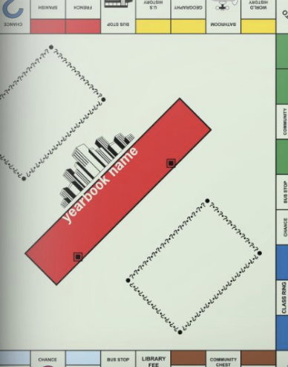
The theme this year is “Board Games” and backgrounds
inside the yearbook will follow these images:

Submit art on:
- 8.5 by 11 sheet of white art paper (for example: watercolor paper/cardstock)
  - Sheets can be provided to students
- Vertical orientation

All entries must include:
- The words “Torrance Elementary School”
- The dates “2021-2022”

Tips for a good entry:
- LOTS OF COLOR (including background) - Not a lot of white space
- Mix up your medium (play with one or more of the following: crayons, markers, paint, oil pastels, collage)
- Use up the whole sheet of paper (the bigger image the better)

Questions? Email ptatorranceelem@gmail.com

Attach this form to your drawing with a PAPER CLIP and return to your teacher.

Student Name:_________________________________________
Teacher/Room Number:__________________________________
Parent Name:__________________________________________
Email/Phone:___________________________________________

Covers will be voted on by the entire Torrance Elementary Student Body!
GOOD LUCK

